# Conflicts in the equal method from Simple Feature Access

One interesting issue has raised during the development of the GeoSPARQL’s geometry topology extension-the relate query function. When we testing the relate function, one synthetic RDF data is used to verify the precision of the function. Since previously we have successfully tested all the functionalities of the topological functions from the three relation families, therefore, the test of relate function is initially designed to reuse the queries in those tests but using the relate function. For example, Figure 1 demonstrates the query for testing the sfEquals query function.

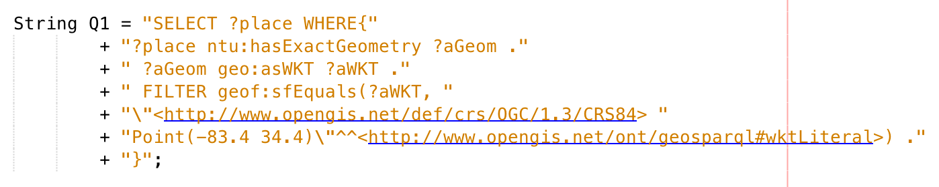

Figure : The query for testing the sfEquals query function.

Then, when using this query to test the relate function, just simply replace the function URI, and then add the extra parameter for relate function-the intersection matrix. Figure 2 shows the corresponding query for testing the relate function using the intersection matrix "TFFFTFFFT", which is the intersection matrix for simple feature equals.

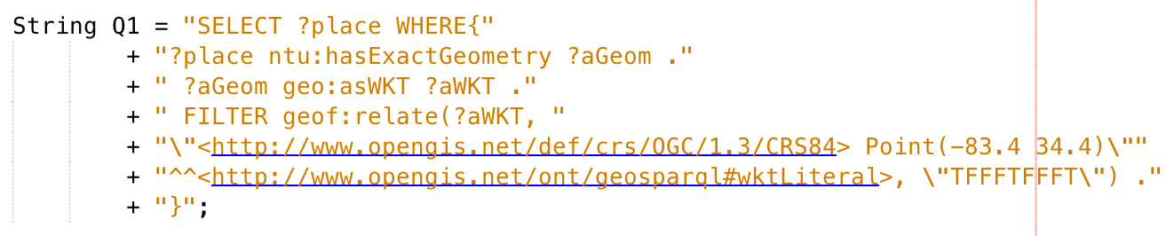

Figure : The modified query for testing the relate function using the intersection matrix "TFFFTFFFT", which is the intersection matrix for simple feature equals.

Ideally, all the modified queries, which are captured from the queries for testing topological functions from the three relation families, should have a same result. Although the test results for testing polygon (polygon to all geometry types) and line string (line string to all geometry types) are exactly same as the results for the topological function tests, the test for point to point scenario is failed as the query from Figure 2 yields no result.

After carefully exclude the mistakes and bugs form the program, we finally find out where the problem comes from-the intersection matrix. According to OGC Simple Feature Access document (Herring 2011, p. 10), “the boundary of a point (the only 0D primitive object type in geometry) is empty”. Thus, according to the DE-9IM model, two equal point geometries should have an intersection matrix like the following table, in other words, the intersection matrix of these relation should be “0FFFFFFF2” where “0” stands for 0-dimensional geometry and “2” stands for 2-dimensional geometry. Since the boundary of point is empty, so their intersection should be empty(False) as well. Nevertheless, the OGC simple feature access explicitly states the intersection matrix for equal function is “TFFFTFFFT”, which means the two equal geometries should have a same-and-not-empty boundary set as well.

Table : The DE-9IM intersection matrix of two equal points.

|  |  |  |  |  |
| --- | --- | --- | --- | --- |
|  | | Point B | | |
| Interior | Boundary | Exterior |
| Point  A | Interior | Not empty | Empty | Empty |
| Boundary | Empty | Empty | Empty |
| Exterior | Empty | Empty | Not empty |

Obviously the definition of the equal function conflicts with the point to point scenario. Actually, according to JTS document and the ESRI website, they define a more general pattern for testing the topological equivalence for two geometries “T*F**FFF*”. This intersection matrix perfectly solves the previous conflict for the point-to-point scenario.